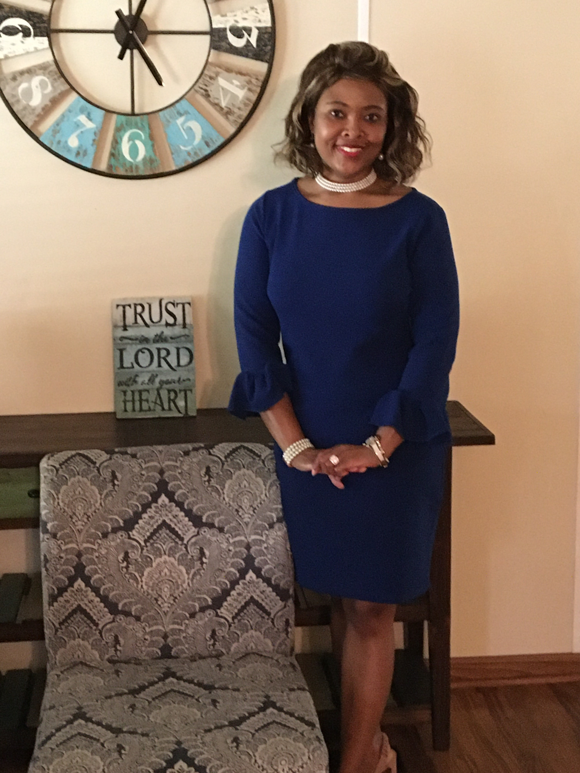  Meet the Counselor  Hello! I am Agatha Rackley-Grant, and I am very proud and excited to be appointed as Wilson Hall Middle School’s new guidance counselor. Although this will be my first year at Wilson Hall, I have been employed by the Clarke County Board of Education as an English teacher for the past 18 years and the assistant counselor for one year at Clarke County High School. I’ve also had the opportunity to work with students at Coastal Alabama Community College as an Upward Bound instructor as well as an adjunct English professor. I received my education from the University of West Alabama where I earned a Bachelor’s degree in English Education, a Master’s and Educational Specialist degrees in School Counseling, and most recently an Instructional Leadership certification. I am so excited to transition into this new phase of my career, and I feel blessed and privileged to be expanding my Clarke County family as I work with the students, parents, administration, faculty, and staff at WHMS.  Mission Statement  The mission of Wilson Hall Middle School’s comprehensive school counseling and guidance program is to prepare every student socially, academically, and emotionally for present and future challenges. Students are provided with opportunities to gain an understanding of self and others, to participate in educational and occupational exploration, and to pursue career planning opportunities in an environment that is safe, caring, and encouraging. The counselor works in collaborative partnerships with students, educators, parents, and community members to empower students to reach their highest level as productive members of society.
  Benefits for Students
  - Ensures student access to school counseling
  - Monitors and interprets data to facilitate student success
  - Provides strategies for closing the achievement gap
  - Promotes challenging and appropriate academic curriculum
  - Advocates for students and promotes equitable access to education opportunities
  Benefits for Parents
  - Supports active partnerships for student learning and career planning
  - Invites and coordinates access to school and community resources
  - Provides training and informational workshops
  - Provides data for information on student progress
  Benefits for Administrators and Staff
  - Promotes an interdisciplinary team approach to address student needs and educational goals
  - Develops and implements a guidance program that promotes student success and enhances school climate
  Contact Information:
  401 Carter Drive
  Grove Hill, AL 36451
  251-250-2140
  arackley@clarkecountyschools.org
Wilson Hall Middle School Counseling Program

